Assignment Subject Questions.

Team 9

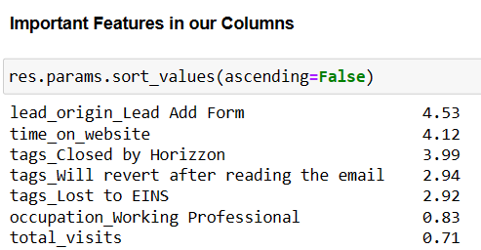

1. Which are the top three variables in your model which contribute most towards the probability of a lead getting converted?

Ans :

* time_on_website:

Positive Contribution

Higher the time spent on website, higher is the probability of lead converting into a customer

Sales team should focus on such leads.

* Lead_origin_lead Add form

Positive Contribution

Lead Origins are coming form lead add forms should be forcused on.

* tags_Will revert after reading the email

positive contribution

if the person has read the email, he/she has a higher chance to get converted into a lead.

Sales team can focus on this variable.

2. What are the top 3 categorical/dummy variables in the model which should be focused the most on in order to increase the probability of lead conversion?

Ans :

1. lead_origin_lead add form
2. tags_closed by horizon
3. tags_will_revert after reading the email.

#### 3. 3. X Education has a period of 2 months every year during which they hire some interns. The sales team, in particular, has around 10 interns allotted to them. So, during this phase, they wish to make the lead conversion more aggressive. So, they want almost all of the potential leads (i.e., the customers who have been predicted as 1 by the model) to be converted and hence, want to make phone calls to as much of such people as possible. Suggest a good strategy they should employ at this stage.

* Target leads that spend a lot of time on X-Education site (Total Time Spent on Website)
* Target leads that repeatedly visit the site (Page Views Per Visit). However they might be repeatedly visiting to compare courses from the other sites, as the number of visits might be for that reason. So the interns should be a bit more aggressive and should ensure competitive points where X-Education is better, are strongly highlighted.
* Target leads that have come through References as they have a higher probability of converting
* Students can be approached, but they will have a lower probability of converting due to the course being industry based. However, this can also be a motivating factor to ensure industry readiness by the time they complete their education

4. Similarly, at times, the company reaches its target for a quarter before the deadline. During this time, the company wants the sales team to focus on some new work as well. So, during this time, the company’s aim is to not make phone calls unless it’s extremely necessary, i.e., they want to minimize the rate of useless phone calls. Suggest a strategy they should employ at this stage.

* Do not focus on unemployed leads. They might not have a budget to spend on the course
* Do not focus on students, since they are already studying and would not be willing to enroll into a course specially designed for working professionals, so early in the tenure